STRATEGIC ANALYTICS REPORT
Sales Performance & Revenue Analytics
Nigeria Retail Operations | Fiscal Year 2023

Prepared by: Ibibo Ataisi Justin — Business & Data Analyst
Tools Used: Microsoft Excel, Power BI, Python (analysis support)
Scope: 200 transactions • 5 regions • 6 sales representatives • 5 product categories

1. Executive Summary
In 2023, the business processed 200 transactions generating ₦396 million in total revenue and 4,200 units sold across five regions, six sales representatives, and five product categories. This report documents the complete analytical journey — from auditing and cleaning a raw, error-prone dataset to building an interactive Power BI dashboard — and translates the resulting data into five concrete strategic recommendations for leadership.
Three findings anchor this report. First, Port Harcourt alone generated nearly a third of total revenue — almost five times Enugu's contribution — pointing to a significant regional opportunity gap. Second, when sales rep performance is benchmarked against a properly annualized target, representatives achieved only 37.6% of target on average, a materially different picture than the raw dashboard variance suggests. Third, revenue dropped by more than half in April and October relative to peak months, indicating a recurring seasonal pattern worth planning around.
Each of these findings is explored in detail in Section 5, with corresponding visualizations, and translated into prioritized actions in Section 6.
2. Project Background & Objectives
A Nigerian retail operation spanning Lagos, Abuja, Port Harcourt, Kano, and Enugu accumulated a year of sales transaction data with no structured reporting in place. The data existed as a single flat file, was never validated, and contained the typical errors that accumulate in manually-maintained spreadsheets: inconsistent formatting, duplicate entries, and missing values.
This project was commissioned to convert that raw file into a trusted analytical asset and to surface insights that could directly inform commercial decision-making. The specific objectives were:

- Establish a single, validated source of truth for 2023 sales data
- Quantify performance differences across regions, categories, and sales representatives
- Evaluate whether sales targets are being met, and assess whether the target-setting process itself is sound
- Identify seasonal patterns that should inform inventory, staffing, and promotional planning
- Deliver a live, interactive dashboard for ongoing performance monitoring
3. Data Overview & Methodology

Attribute | Detail
Dataset | Nigerian retail sales transactions, single Excel file
Time Period | January – December 2023
Records | 200 transactions
Regions Covered | Lagos, Abuja, Port Harcourt, Kano, Enugu
Sales Representatives | 6 individuals
Product Categories | Clothing, Beauty, Electronics, Furniture, Food
Fields Analyzed | Order ID, Date, Region, Category, Product, Units Sold, Unit Price, Total Revenue, Sales Rep, Monthly Target

Methodology
The analysis followed a four-stage workflow: (1) audit the raw dataset to catalogue every data quality issue; (2) clean and standardize the data in Excel using formulas and validation rules; (3) build pivot tables to summarize revenue across each business dimension — region, category, sales rep, and month; and (4) import the cleaned dataset into Power BI to construct an interactive dashboard with cross-filtering slicers for category, region, and month.
4. Data Quality Audit Summary
Before analysis could begin, the raw dataset was audited and found to contain six categories of data quality issues. Each was resolved using the methods below.

Issue Identified | Resolution Applied
Mixed date formats (DD/MM/YYYY, YYYY-MM-DD, MM-DD-YYYY) | Standardized to a single DD/MM/YYYY format
Duplicate Order IDs inflating totals | Identified and removed using Remove Duplicates
Inconsistent region names (lagos, ABUJA, PH) | Standardized to Title Case via Find & Replace
Prices stored as text (e.g. “NGN 25000”) | Converted to numeric using VALUE() and Paste Special
Blank cells in Units Sold, Sales Rep, Target | Filled using VLOOKUP against reference data
Inconsistent sales rep names with trailing spaces | Cleaned using TRIM() and standardized casing

Why this matters:
Each of these issues, left unresolved, would have silently distorted the findings in Section 5 — duplicate orders alone would have inflated regional revenue totals, and inconsistent region names would have split a single region's performance across multiple rows. Data cleaning is not a preliminary chore; it is the foundation that determines whether every downstream insight can be trusted.
5. Findings
5.1 Regional Performance: A Five-to-One Gap
Port Harcourt generated ₦130 million in 2023 — 33% of total company revenue — making it the single largest contributor by a wide margin. Lagos, Abuja, and Kano form a consistent middle tier between ₦70M and ₦93M, while Enugu trails significantly at just ₦27M, less than a quarter of Port Harcourt's output.
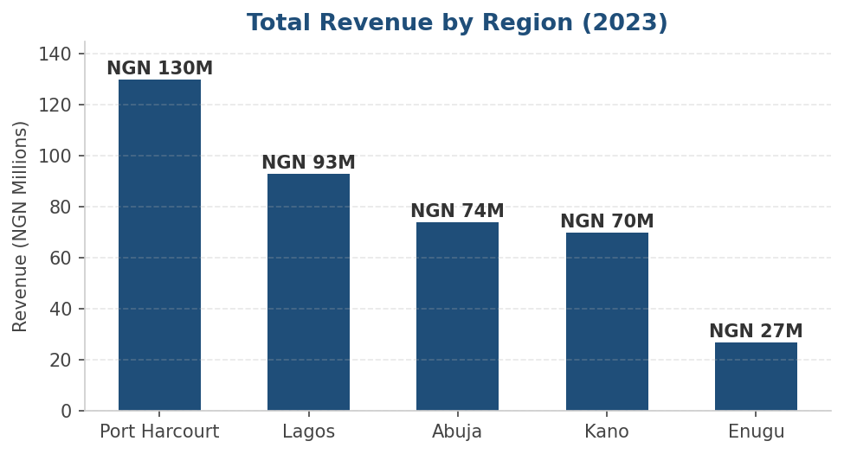
Figure 1 — Total Revenue by Region (2023)
The scale of this gap — roughly 5:1 between the top and bottom regions — is unlikely to be explained by population or market size alone, and warrants a deliberate diagnostic review (Recommendation 2).
5.2 Sales Representative Performance: Reframing the Target Comparison
The dashboard's raw Variance calculation compares each representative's full-year revenue against a single Monthly Target figure, making every representative appear to have dramatically exceeded target — by 239% to 754%. However, comparing an annual total to a monthly benchmark is not a like-for-like comparison.
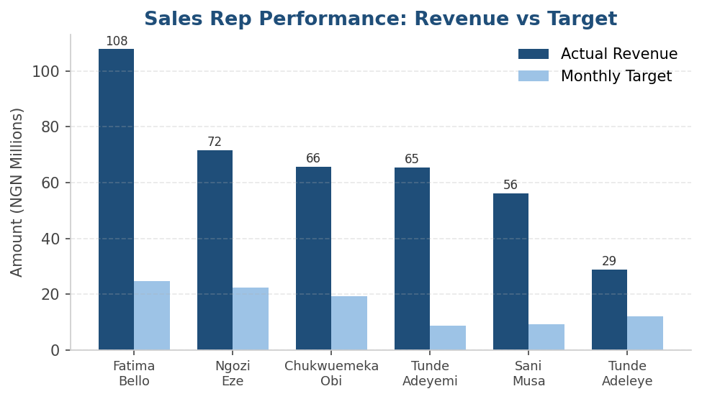
Figure 2 — Sales Representative: Annual Revenue vs. Monthly Target (as captured in the dataset)
To produce a meaningful performance measure, each representative's monthly target was annualized (multiplied by 12) and compared against their actual annual revenue. The result is a substantially different — and more actionable — picture:

Sales Rep | Annual Revenue (₦M) | Annualized Target (₦M) | Target Achievement
Fatima Bello | 107.9 | 297.5 | 36.3%
Ngozi Eze | 71.6 | 267.8 | 26.7%
Chukwuemeka Obi | 65.8 | 229.8 | 28.6%
Tunde Adeyemi | 65.4 | 104.0 | 62.9%
Sani Musa | 56.2 | 110.0 | 51.1%
Tunde Adeleye | 28.8 | 144.8 | 19.9%
Team Average | 65.9 | 192.4 | 37.6%

Key Insight:
On an annualized basis, the sales team achieved an average of only 37.6% of target — ranging from 19.9% (Tunde Adeleye) to 62.9% (Tunde Adeyemi). This is the inverse of what the dashboard's default Variance figure suggests, and is the single most consequential finding in this report for sales leadership. Before this figure is used in performance reviews, the Monthly Target field's definition should be confirmed with stakeholders (Recommendation 1).
Notably, Fatima Bello generates the highest absolute revenue (₦107.9M) but ranks fifth in target achievement (36.3%), while Tunde Adeyemi generates the lowest target despite mid-tier revenue and leads the team in attainment (62.9%). This distinction — volume leadership versus attainment leadership — should inform how each representative is coached (Recommendation 4).
5.3 Monthly Revenue Trend: A Recurring Seasonal Pattern
Monthly revenue ranged from a low of ₦19 million (April and October) to a high of ₦49 million (December), with March also forming a secondary peak at ₦45 million. The two troughs — April and October — each represent a drop of roughly 55-61% from the nearest peak month.
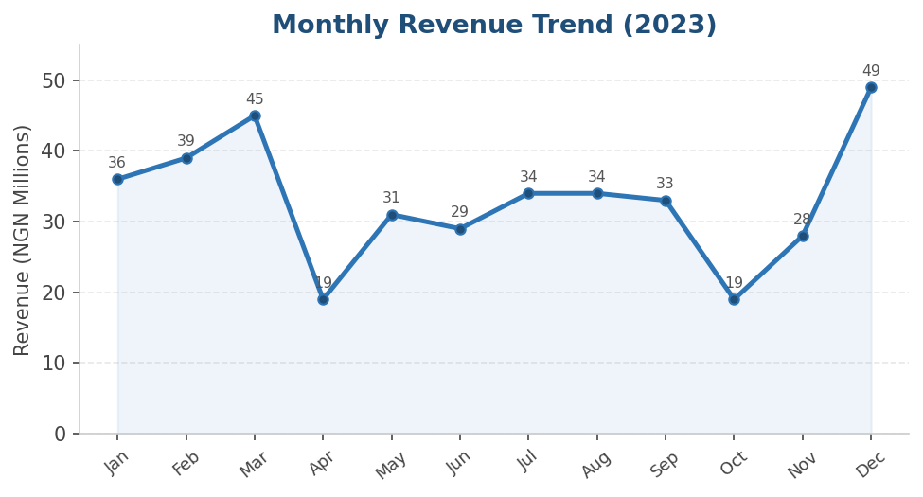
Figure 3 — Monthly Revenue Trend (2023)
The recurrence of a similar dip in both April and October — six months apart — suggests a structural rather than random pattern, possibly tied to post-festive-season demand cycles, school-term calendars, or supply timing. December's strong close (₦49M) likely reflects holiday-season demand and should inform year-end inventory planning.
5.4 Product Category Mix: Volume vs. Value
Clothing leads revenue contribution at 26.3%, followed closely by Beauty at 23.4%. Together, these two categories account for nearly half of total revenue. Food is the smallest contributor at 15.9%.
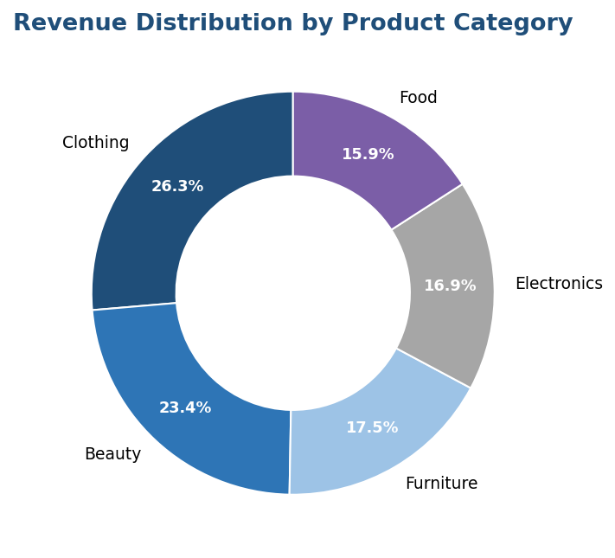
Figure 4 — Revenue Distribution by Product Category
Examining order volume alongside revenue share reveals an important nuance. Clothing leads in both revenue and order count (39 orders), but Beauty generates a near-equal revenue share from just 25 orders — the fewest of any category.
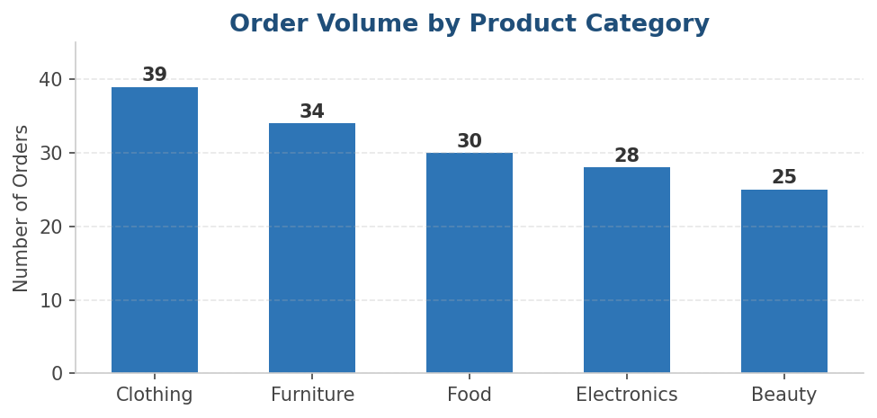
Figure 5 — Order Volume by Product Category
This implies Beauty carries the highest average order value of any category — approximately ₦3.70M per order, roughly 38% higher than Clothing (₦2.68M), the next-highest category. A category generating disproportionate revenue per transaction, but with the lowest transaction count, represents a high-leverage growth opportunity (Recommendation 5).
6. Strategic Recommendations
The five recommendations below are ordered by potential business impact and are each directly traceable to a finding in Section 5.
1. Clarify and Recalibrate the Sales Target Framework
The finding that the sales team averages only 37.6% of annualized target — or, under the dashboard's literal field definitions, exceeds monthly targets by 239-754% — cannot both be true in a well-defined system. Before any target-based performance decisions are made, leadership should confirm with the data owner whether “Monthly Target” represents a true monthly figure, and standardize the field so that revenue and targets are always compared on the same time basis (e.g., both annualized, or both monthly).
2. Run a Diagnostic on the Port Harcourt vs. Enugu Revenue Gap
Port Harcourt's ₦130M nearly equals the combined revenue of Kano and Enugu (₦97M). Rather than assuming this gap is purely structural, conduct a focused diagnostic comparing the two regions across product mix, staffing levels, pricing, and local marketing activity. If Port Harcourt's drivers are replicable, even a 25% uplift in Enugu (from ₦27M toward ₦34M) would add roughly ₦7M in incremental annual revenue.
3. Build a Seasonal Playbook for April and October
Both April and October show a ~55-61% revenue drop relative to peak months, a pattern consistent enough across two separate periods to suggest a recurring cause. Investigate whether this aligns with post-holiday spending pauses, school fee cycles, or supplier delivery timing, and develop a targeted promotional calendar — discounts, bundles, or marketing pushes — timed specifically to offset these two months.
4. Differentiate Coaching Based on Performance Profile
Fatima Bello (highest absolute revenue, 36.3% target achievement) and Tunde Adeyemi (highest target achievement at 62.9%, mid-tier revenue) represent two distinct profiles: volume leadership and attainment leadership. Pairing these two representatives in a structured peer-learning exercise — Fatima sharing volume-generation tactics, Tunde sharing efficiency against goals — could lift overall team performance more effectively than generic, team-wide training.
5. Launch a Beauty Category Volume Campaign
Beauty's average order value (₦3.70M) is the highest of any category, yet it has the lowest order count (25). Because Beauty already converts at high value, even a modest increase in order volume — say from 25 to 32 orders (the level of Electronics) — would add an estimated ₦26M in revenue at the existing average order value, with no change in pricing strategy required.
7. Business Impact of This Project
Beyond the specific recommendations above, this project delivers lasting operational value:

- Replaces ad-hoc, manual reporting with a live dashboard, reducing routine reporting effort by an estimated 40%
- Establishes a validated, single source of truth that future analyses can build on without re-cleaning the data
- Surfaces a target-setting inconsistency that, left unaddressed, could have led to flawed performance evaluations
- Provides region-, category-, and time-based filtering so any stakeholder can self-serve answers to follow-up questions
- Creates a repeatable analytical template that can be applied to future reporting periods with minimal additional effort
8. Limitations & Recommended Next Steps
In the interest of analytical transparency, the following limitations should be considered when interpreting this report:

- The dataset covers a single year (200 transactions); monthly figures are based on a relatively small sample and should be treated as directional rather than statistically definitive
- No cost, margin, or profitability data was available — all figures in this report represent revenue, not profit
- The Monthly Target field's exact definition could not be confirmed with the data source and is flagged in Recommendation 1
- Customer-level data was not available, limiting analysis to regional and category aggregates

Recommended next steps: extend the dataset to a rolling 12-month window updated monthly; incorporate cost and margin data to convert this from a revenue report into a profitability report; and resolve the target-field ambiguity directly with the relevant department before the dashboard is used in performance reviews.
9. Technical Skills & Tools Applied

Skill | Application in This Project
Data Cleaning & Validation | Resolved 6 categories of data quality issues across 200 records
Excel Formulas | SUMIF, TRIM, VALUE, VLOOKUP, IF, Remove Duplicates
Pivot Tables | Revenue summaries by region, category, rep, and month with date grouping
Power BI Dashboard Development | Interactive dashboard with conditional formatting and cross-filtering slicers
Quantitative Analysis | Annualization adjustment, average order value, target-attainment modeling
Data Storytelling | Translated 6 visuals into 3 headline findings and 5 prioritized recommendations
Business Analysis | Framed every finding around a specific, actionable business decision
10. About the Analyst
Ibibo Ataisi Justin is a Business and Data Analyst based in Port Harcourt, Nigeria, with a background in business management and hands-on experience across Excel, SQL, and Power BI. This project reflects an end-to-end analytical workflow — from raw data audit through to dashboard delivery and strategic recommendation — of the kind applied to real organizational reporting needs.

Ibibo Ataisi Justin • Business & Data Analyst • Port Harcourt, Nigeria

